Kunhui Zhang (001563549)

**Program Structures & Algorithms**

**Fall 2021**

**Assignment No. 5 (Parallel Sorting)**

* **Task (List down the tasks performed in the Assignment)**

1. Update the suitable value of cutoff, and run experiments with many different array sizes and different cutoff schemes.
2. Decide on an ideal number of separate threads(stick to powers of 2) and arrange for the number of partitions to be parallelized.
3. Draws graphs and write a report that shows the results of experiments about the efficacy of this method of parallelizing sort.

* **Relationship Conclusion: (For ex : z = a * b)**

a) According to the experiments, **the ideal number of thread is 16(degree = 4)**. Because the running time of other threads before thread = 16 is more, and the running time of threads after thread = 16 has no obvious change.

b) Holding the unchanged thread number, I changed the size of array to find the suitable value of cutoff. The result is that ratio of cutoff from 25% to 50% is the better scale than other areas.

* **Evidence to support the conclusion:**

1. **Output (Snapshot of Code output in the terminal)**
2. ideal thread

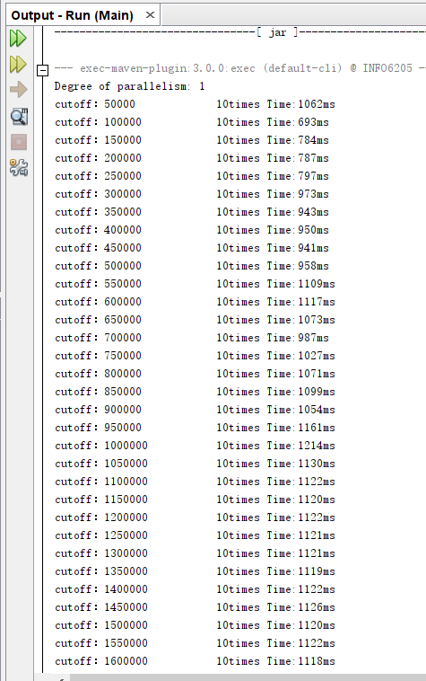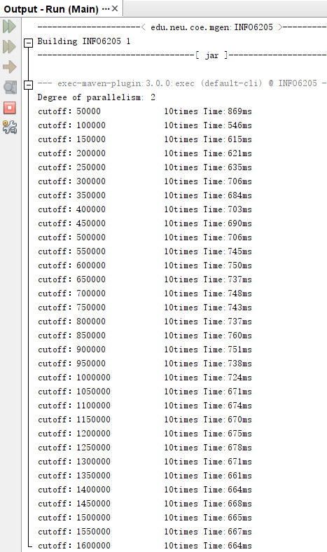

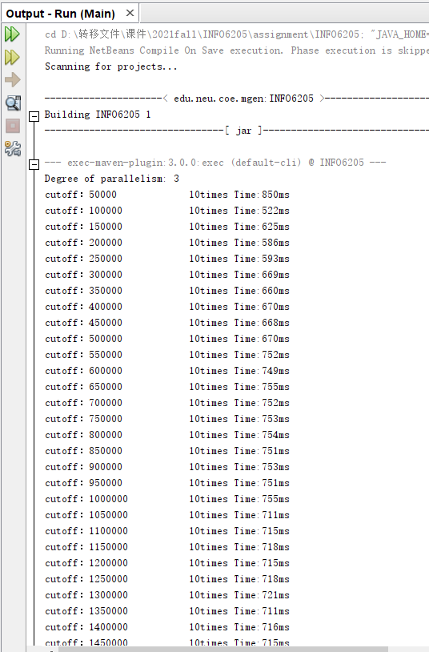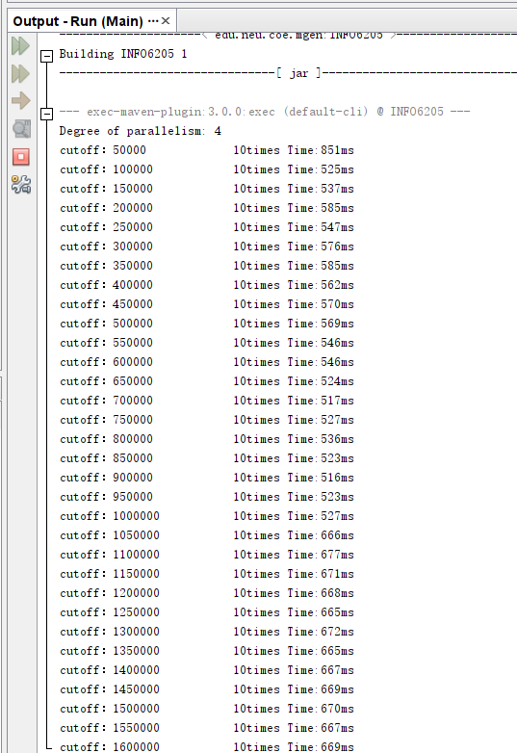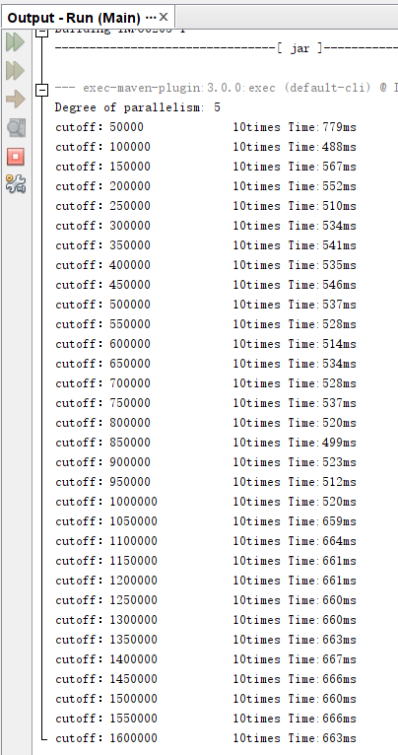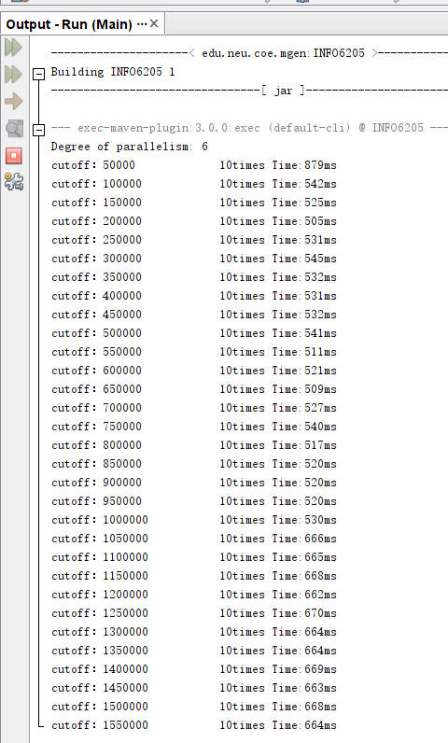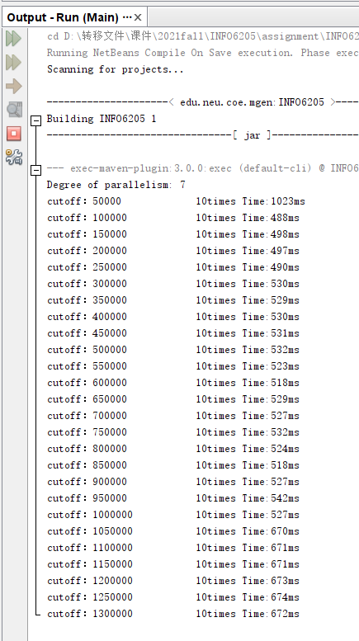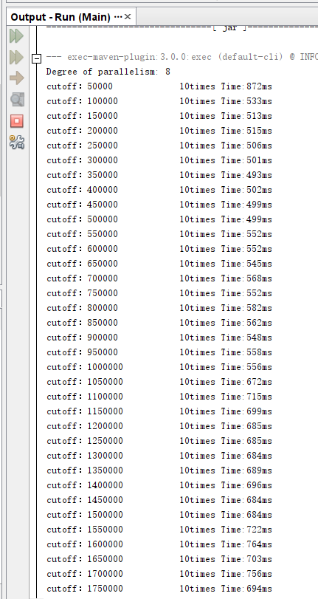

Screenshots above are the output in different threads.

b)suitable cutoff

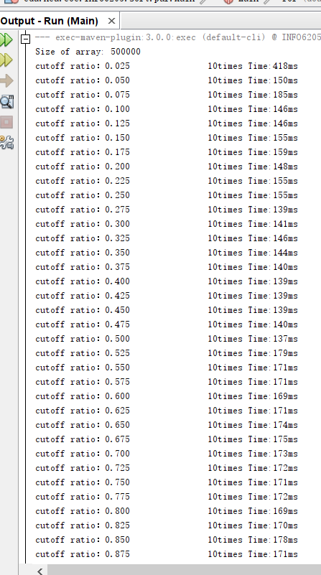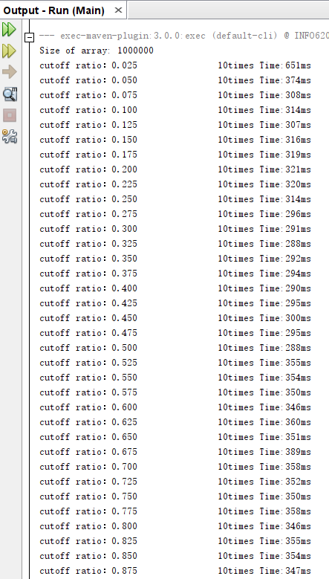

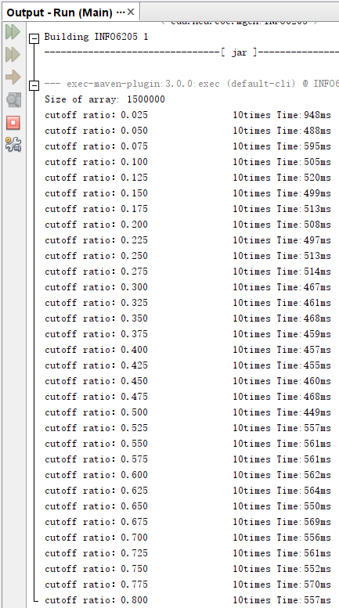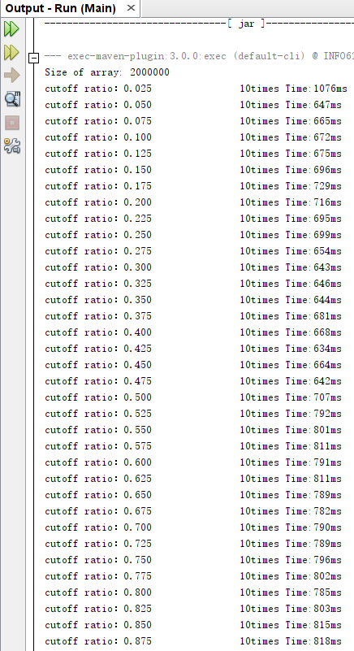

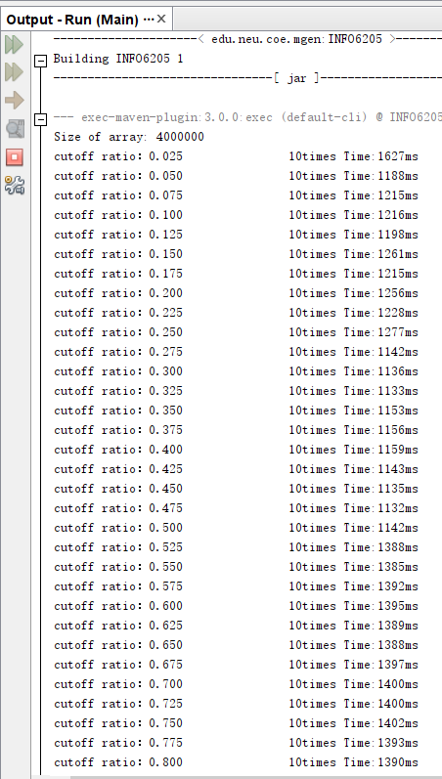

Screenshots above are the output in different array sizes.

1. **Graphical Representation(Observations from experiments should be tabulated and analyzed by plotting graphs(usually in excel) to arrive on the relationship conclusion)**

a) ideal thread

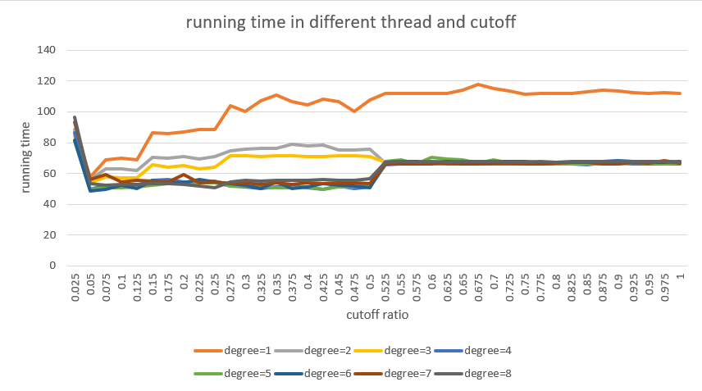

In this graph, it is easy to find that the running time has no obvious change after degree = 4( thread number is 16).

b) suitable cutoff

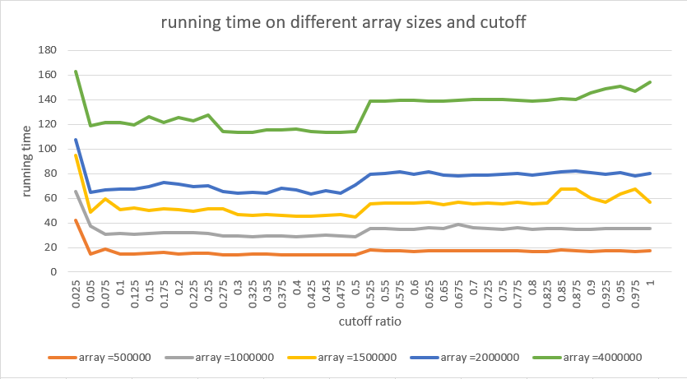

From this picture, the running time is less than others when the ratio of cutoff between 25% and 50%.